**Development of a Comprehensive Blood Bank Management System Using Java with Object-Oriented Programming Principles**

## A MINI PROJECT REPORT

***Submitted by***

**JYOSTNA J (231801075)**

**JEIYA SATHVIHAA A (231801070)**

***in partial fulfillment for the award of the degree of***

**BACHELOR OF TECHNOLOGY**

## IN

ARTIFICIAL INTELLIGENCE AND DATA SCIENCE



**RAJALAKSHMI ENGINEERING COLLEGE,**

**ANNA UNIVERSITY: CHENNAI 600025**

DEC 2024

ANNA UNIVERSITY: CHENNAI – 600 025

# BONAFIDE CERTIFICATE

Certified that this project report “**Development of a Comprehensive Blood Bank Management System Using Java with Object-Oriented Programming Principles**” is the bonafide work of “**JEIYA SATHVIHAA A (231801070), JYOSTNA J (231801075),**” who carried out the project work under my supervision.

**SIGNATURE SIGNATURE**

**Dr. Sekar K, M.E ., Ph.D., Mrs. RENUKA DEVI**

**HEAD OF THE DEPARTMENT SUPERVISOR**

**AND PROFESSOR AND ASSISTANT PROFESSOR**

Department of Artificial Intelligence Department of Artificial Intelligence and Machine Learning, and Machine Learning,

Rajalakshmi Engineering College Rajalakshmi Engineering College Thandalam, Chennai – 602 105 Thandalam, Chennai

Submitted for Project Viva-Voce Examination held on .

## INTERNAL EXAMINER EXTERNAL EXAMINER

**TABLE OF CONTENTS**

|  |  |  |
| --- | --- | --- |
| **CHAPTOR NO** | **TITLE** | **PAGE NO** |
| **01** | **INTRODUCTION** | **01** |
|  | 1.1Project definition | **01** |
|  | 1.2. Need for the proposed system | **03** |
|  | 1.3. Application of proposed system | **04** |
| **02** | **LITERATURE REVIEW** | **06** |
| **03** | **PROBLEM FORMULATION** | **09** |
|  | 3.1. Main objective |  |
|  | 3.2. Specific objective | **11** |
|  | 3.3. Methodology | **13** |
| **04** | **SYSTEM ANALYSIS** | **15** |
|  | 4.1. Fact finding | **1509** |
|  | 4.2.Feasibiity analysis | **16** |
|  | 4.3. Model architecture design | **18** |
| **05** | **FUNCTIONAL DESCRIPTION** | **19** |
| **06** | **SYSTEM DEVELOPMENT TESTING AND IMPLEMENTATION** | **20** |
|  | 6.1. System development | **20** |
|  | 6.2. testing | **21** |
|  | 6.3. Implementation | **23** |
|  | 6.4. Dataset | **25** |
| **07** | **CONCLUSION AND FUTURE ENHANCEMENTS** | **26** |
|  | 7.1. CONCLUSION | **26** |
|  | 7.2. Future enhancements | **26** |
|  | **APPENDIX-1** | 27 |
|  | Sample code | **27** |
|  | **APPENDIX-2** | 31 |
|  | Output screenshots | 31 |
|  | **REFERENCES** | 32 |

## ACKNOWLEDGEMENT

Initially, we thank the Almighty for being with us through every walk of our life and showering his blessings through the endeavor to put forth this report. Our sincere thanks to our Chairman **Mr. S. MEGANATHAN, B.E, F.I.E.**, our Vice Chairman **Mr. ABHAY SHANKAR MEGANATHAN, B.E., M.S.**, and our

respected Chairperson **Dr. (Mrs.) THANGAM MEGANATHAN, Ph.D.**, for providing us with the requisite infrastructure and sincere endeavoring in educating us in their premier institution.

Our sincere thanks to **Dr. S.N. MURUGESAN, M.E., Ph.D.**, our beloved Principal for his kind support and facilities provided to complete our work in time. We express our sincere thanks to **Dr. K. SEKAR, M.E, Ph.D.**, Head of the Department of Artificial Intelligence and Machine Learning for his guidance and encouragement throughout the project work. We convey our sincere and deepest gratitude to our internal guide, **Mrs. Y. NIRMALA ANANDHI, M.E.,** Assistant Professor Department of Artificial Intelligence and Machine Learning, Rajalakshmi Engineering College for her valuable guidance throughout the course of the project. We are very glad to thank our Project Coordinator, **Mrs. RENUKA DEVI, M.E.,** Assistant Professor Department of Artificial Intelligence and Data Science for his useful tips during our review to build our project.

**JYOSTNA J (231801075)**

## JEIYA SATHVIHAA A(231801070)

**ABSTRACT**

The **Blood Bank Management System** is an advanced software solution designed to simplify the operations of blood banks by leveraging Java programming and Object-Oriented Programming (OOP) principles. This mini-project aims to provide a robust platform for managing donor information, blood inventory, and donation history while ensuring data accuracy and operational efficiency. With the increasing demand for timely blood availability in medical emergencies, this system addresses the need for streamlined data management and retrieval processes.

The system uses Java as the primary programming language, offering cross-platform compatibility and scalability. By adopting OOP principles, the project emphasizes modularity, code reusability, and ease of maintenance. Core functionalities include managing donor registrations, tracking available blood units by type, and recording donation dates. The application employs MySQL as the backend database, connected via the JDBC driver to ensure secure and efficient data storage and retrieval. This integration facilitates the management of large datasets, ensuring reliability and real-time updates.

The system's architecture includes user-friendly interfaces for administrators and staff to access or update donor records and blood inventory. Features such as automated alerts for low stock levels and a seamless search for specific blood groups enhance the system's utility. The design ensures data integrity through validation mechanisms and minimizes human errors associated with manual record-keeping.

The project also incorporates a modular structure, with classes representing entities such as donors, blood types, and inventory items. These classes encapsulate data and behavior, promoting abstraction and enhancing system robustness. Additionally, the system supports CRUD (Create, Read, Update, Delete) operations, enabling efficient data management.

Comprehensive testing has been conducted to validate the system's performance under different scenarios. Potential limitations, such as dependency on internet connectivity for remote database access, have been identified and documented for future improvement. The system is adaptable to enhancements like online appointment scheduling and integration with hospital networks.

In conclusion, the Blood Bank Management System exemplifies the application of OOP principles in solving real-world problems. It provides a scalable, efficient, and user-friendly solution for managing critical blood bank operations. This project serves as a foundation for further exploration into healthcare technology systems, with potential for significant impact on public health outcomes.

**CHAPTER 1**

**INRODUCTION**

* 1. **PROJECT DEFINITION**

The Blood Bank Management System is a comprehensive software solution designed to streamline the operations of blood banks by automating the management of donor information, blood inventory, and donation records. This system aims to address the challenges faced by blood banks in managing critical data efficiently, ensuring timely blood availability, and reducing human errors associated with manual record-keeping.

Developed using Java and leveraging Object-Oriented Programming (OOP) principles, this project provides a modular and scalable platform that supports various functionalities such as donor registration, tracking available blood units by type, recording donation history, and maintaining an accurate blood inventory. By using Java's platform-independent nature, the system ensures that it can run on different devices and operating systems, making it versatile and adaptable to various blood bank environments.

The system utilizes MySQL as the backend database, enabling secure and reliable data storage. Through the integration of Java Database Connectivity (JDBC), the application ensures seamless communication between the software and the database, providing real-time data updates. This allows blood bank administrators and staff to access and manage critical data with ease, ensuring quick responses during medical emergencies when blood is required urgently.

Key features of the system include user-friendly interfaces for managing donor and blood inventory records, automated alerts for low blood stock, and the ability to search for specific blood groups. The system also supports CRUD (Create, Read, Update, Delete) operations, ensuring flexibility in data management. The project’s modular structure enables future enhancements, such as online appointment scheduling for blood donations or integration with hospital networks.

The project is designed with security in mind, ensuring that sensitive donor information is protected and preventing unauthorized access. Through data validation and error handling mechanisms, the system ensures data integrity and accuracy, further enhancing its reliability.

* 1. **NEED FOR THE PROPOSED SYSTEM**

The increasing demand for blood in medical emergencies, surgeries, and treatments has made it crucial for blood banks to maintain efficient operations. However, many blood banks still rely on manual processes or outdated systems, which can lead to errors, inefficiencies, and delays in providing blood supplies when they are most needed. The need for an automated and reliable system to manage blood donations, donor information, and inventory is more important than ever. The proposed Blood Bank Management System aims to address these challenges by offering a streamlined, accurate, and scalable solution for managing blood bank operations.

1. **Efficient Management of Donor and Blood Inventory Data**: Blood banks manage a large amount of data, including donor details, blood types, donation histories, and inventory levels. Manual tracking or fragmented systems can lead to data inaccuracies, duplication, or loss of information. The proposed system centralizes this data, ensuring that information is stored securely, easily accessible, and up-to-date. This allows blood bank staff to quickly access and manage donor records and blood stock, ensuring that the right blood type is available when required.
2. **Reduction in Human Error**: Manual record-keeping and data entry are prone to human error, such as incorrect donor information, mismatched blood types, or missed donations. The proposed system minimizes these risks by automating data entry, applying validation checks, and providing real-time updates. This ensures that blood bank operations are accurate and reliable, reducing the likelihood of errors that could compromise patient care.
3. **Timely Availability of Blood**: The availability of blood units can fluctuate depending on donor participation and demand. Blood banks often face challenges in managing these fluctuations, especially in emergencies. The Blood Bank Management System provides real-time tracking of blood inventory, enabling administrators to quickly identify shortages or surplus blood types. Automated alerts for low blood stocks ensure timely replenishment, reducing the risk of running out of critical blood types when emergencies arise.
4. **Efficient Data Retrieval**: Searching for specific donor records, blood types, or donation histories manually can be time-consuming and inefficient. The proposed system simplifies this process with an advanced search function that allows staff to quickly retrieve information based on multiple criteria, such as donor name, blood type, or donation date. This speeds up data retrieval and supports faster decision-making, especially in urgent situations.
5. **Scalability and Future Enhancements**: As blood banks expand or as healthcare requirements evolve, the system must be adaptable to future needs. The modular nature of the proposed system, built using Object-Oriented Programming (OOP) principles, ensures that it can be easily extended to support new features, such as integration with hospital networks, online appointment scheduling for blood donations, or automated reporting tools. This scalability ensures that the system can grow with the blood bank and continue to meet its operational demands.
6. **Data Security and Privacy**: Blood bank systems often handle sensitive personal information about donors, including medical histories and contact details. Protecting this data from unauthorized access is critical. The proposed system incorporates strong security features, such as role-based access control and encrypted data storage, to safeguard donor information and ensure compliance with privacy regulations.
7. **Improved Decision Making**: Real-time and accurate data about blood inventory and donor histories allow blood bank administrators to make informed decisions. Whether it's planning for blood drives, determining which blood types are in demand, or forecasting future needs, the proposed system provides the data needed to make these decisions efficiently and effectively.
   1. **APPLICATION OF THE PROPOSED SYSTEM**

The proposed Blood Bank Management System has wide-ranging applications in the healthcare sector, particularly in the effective and efficient operation of blood banks and related medical institutions. By streamlining the management of blood inventories, donor data, and donation histories, the system offers several benefits that extend beyond basic record-keeping. The following outlines the key applications of the proposed system:

#### 1. **Blood Bank Operations**

The Blood Bank Management System automates essential tasks such as donor registration, blood inventory management, and donation tracking. By centralizing data, the system provides real-time updates, ensuring that blood banks can efficiently track blood types and quantities, reducing errors and improving operational efficiency.

#### 2. **Emergency Medical Situations**

In emergencies, quick access to blood is crucial. The system’s real-time inventory tracking and automated alerts for low blood stock levels ensure blood banks can quickly respond to urgent demands, helping prioritize critical blood types and ensuring no delays in treatment.

#### 3. **Donor Management**

The system simplifies managing donor information, maintaining accurate records of donations, blood types, and eligibility criteria. This ensures safe and efficient blood collection while fostering a reliable database of repeat donors, promoting long-term donor engagement.

#### 4. **Data Reporting and Analysis**

The system allows for easy generation of detailed reports on blood inventory, donor participation, and blood usage. This functionality supports decision-making, resource planning, and compliance with regulations, ensuring blood banks can optimize operations and meet demand efficiently.

#### 5. **Integration with Hospital Networks**

The system can be integrated with hospital networks, facilitating the smooth transfer of blood between blood banks and hospitals. This integration ensures hospitals are notified of available blood supplies, reducing delays and enabling immediate access to blood when needed.

#### 6. **Blood Donation Drives and Campaigns**

The system enables blood banks to organize and manage donation drives, tracking donor participation and blood collection. It can target specific donor groups based on geographic and blood type needs, optimizing blood collection efforts.

#### 7. **Healthcare Management Systems**

The system can integrate with broader healthcare management systems, ensuring coordination between blood banks, hospitals, and patient care teams. This integration helps streamline patient care by ensuring the availability of blood products during critical treatments.

**CHAPTER 2**

**LITERATURE REVIEW**

The management of blood banks has always been a critical aspect of healthcare, as timely access to blood supplies is essential for saving lives in medical emergencies, surgeries, and treatments. Traditionally, blood banks relied on manual or semi-automated systems, which led to inefficiencies, errors, and challenges in tracking blood donations, inventory, and donor records. With the advent of modern technology, many blood banks are transitioning to automated solutions to improve operational efficiency, enhance data accuracy, and streamline processes. This literature review examines previous studies, technologies, and systems related to blood bank management and highlights the benefits and limitations of existing solutions.

#### 1. **Challenges in Traditional Blood Bank Management**

Traditional blood bank management systems often involve manual record-keeping, leading to significant risks such as data inaccuracy, loss of records, and difficulty in retrieving important information quickly. According to a study by Saha et al. (2018), manual systems in blood banks result in delayed responses during emergencies and contribute to human errors in blood inventory management, including misidentifying blood types or mishandling donor information. These inefficiencies highlight the need for a more automated and reliable system.

#### 2. **Role of Technology in Blood Bank Management**

Technology has played a transformative role in modernizing blood bank operations. Digital systems have been employed to automate the recording and tracking of blood donations, inventory management, and donor histories. A study by Jaya and Manohar (2019) discusses how Information Technology (IT) systems have helped blood banks reduce errors and optimize the tracking of blood types and available stocks. These systems allow for real-time updates and automated alerts, enabling quick decision-making during critical situations.

#### 3. **Database Management in Blood Banks**

The use of databases for managing donor and blood inventory data is a crucial component of modern blood bank systems. Several studies, such as those by Gupta et al. (2020), emphasize the importance of employing database management systems (DBMS) like MySQL or SQL Server to store and manage large datasets efficiently. These systems ensure the secure storage of sensitive donor information, track blood inventories, and allow for easy retrieval of records when needed. The integration of databases with web-based platforms has also made it easier for multiple blood bank locations to share information and coordinate efforts.

#### 4. **Object-Oriented Programming (OOP) in Blood Bank Systems**

Object-Oriented Programming (OOP) principles have been widely adopted in the design of modern blood bank management systems. According to Sharma and Singhal (2021), the use of OOP in blood bank systems allows for better organization, modularity, and maintainability of code. By creating classes for donors, blood types, and inventory, systems can be designed to efficiently manage and update records. OOP allows for easy scalability, ensuring that additional features or functionalities can be added without affecting the existing system.

#### 5. **Challenges of Implementing Automated Systems**

Despite the clear benefits, the implementation of automated blood bank management systems also presents challenges. A study by Lee et al. (2020) discusses the difficulties in transitioning from manual to automated systems, such as resistance to change among staff, the need for extensive training, and the integration of legacy systems with new technology. Additionally, data security concerns and the protection of sensitive donor information are critical issues in the adoption of digital systems. Ensuring compliance with healthcare data protection regulations such as HIPAA in the United States or GDPR in Europe is also essential.

#### 6. **Recent Advances in Blood Bank Management Systems**

Recent advancements in technology have led to the development of more sophisticated and user-friendly blood bank management systems. Mobile applications, cloud-based solutions, and AI-powered analytics are beginning to be incorporated into blood bank systems. For example, cloud technology allows for centralized data storage and real-time data access from multiple locations, improving coordination and management. AI algorithms are also being used to predict blood shortages based on historical data and seasonal demand patterns, helping blood banks plan for upcoming needs more effectively.

#### 7. **Integration with Hospital Networks**

The integration of blood bank systems with hospital networks and Electronic Health Records (EHR) has been highlighted as a key area for improvement in blood management. A study by Patel et al. (2019) emphasized the benefits of real-time data exchange between hospitals and blood banks, enabling hospitals to receive timely updates on blood availability and request specific blood types when needed. This integration can improve patient care by ensuring that the right blood is available at the right time, particularly in emergency situations.

#### 8. **Impact on Public Health**

Efficient blood bank management systems have a direct impact on public health by improving blood supply availability and ensuring the safe and timely delivery of blood to patients in need. According to a report by the World Health Organization (2021), effective blood bank systems can help reduce blood shortages and optimize blood distribution, particularly in areas with high demand. Well-maintained blood banks contribute to better patient outcomes and overall healthcare efficiency.

#### 9. **Limitations of Current Systems**

While automated systems offer significant improvements, they are not without limitations. One major challenge is the dependency on internet connectivity for real-time data access and synchronization. In remote or underdeveloped regions, this may be a barrier to implementing such systems. Furthermore, integrating automated systems with existing infrastructure can be costly and time-consuming, particularly in areas with limited resources.

**CHAPTER 3**

**PROBLEM FORMULATION**

**3.1. MAIN OBJECTIVE**

The main objective of the Blood Bank Management System is to address the challenges faced by blood banks in managing donor data, blood inventory, and donation histories. Blood banks often deal with large amounts of sensitive and critical data, including donor records, blood types, and inventory levels. Manual or outdated systems can lead to errors, inefficiencies, and difficulties in retrieving and updating this data, which can negatively affect patient care and emergency response times. The primary goal of this system is to automate these processes, ensuring real-time tracking of blood stocks, accurate donor management, and efficient donation tracking.

Additionally, the system aims to reduce human error in data entry and processing by implementing validation checks and automated alerts for low blood stock levels. It also strives to improve the speed and accuracy of information retrieval, enabling quick decision-making, especially in urgent medical situations. The system will enhance collaboration between blood banks and hospitals, ensuring that blood products are available when needed most. By integrating modern technologies such as databases and Object-Oriented Programming (OOP), the system will provide scalability, security, and ease of maintenance, setting the foundation for future enhancements in blood bank management.

**3.2. SPECIFIC OBJECTIVE**

The Blood Bank Management System is designed to fulfill several specific objectives to streamline operations, ensure data accuracy, and improve overall efficiency. These objectives are categorized into key focus areas to address the critical requirements of blood bank management.

#### 1. **Efficient Donor Management**

* Maintain detailed donor profiles, including personal information, blood type, donation history, and eligibility status.
* Automate the process of donor registration and validation to reduce errors and save time.
* Track donor health and eligibility for future donations to ensure safe and reliable blood collection.

#### 2. **Inventory Management**

* Monitor blood inventory in real-time, categorizing blood units by type, quantity, and expiration date.
* Automate alerts for low stock levels to ensure timely replenishment of blood supplies.
* Prevent wastage of blood by tracking expiration dates and optimizing usage.

#### 3. **Streamlined Data Retrieval and Reporting**

* Facilitate quick and accurate retrieval of donor and inventory data during emergencies.
* Generate detailed reports on blood stocks, donation trends, and donor activity for analysis and decision-making.
* Support regulatory compliance by maintaining accurate records and providing audit-ready reports.

#### 4. **Enhanced Emergency Response**

* Enable instant identification of available blood types during emergencies.
* Integrate with hospital systems to streamline the transfer of blood units between facilities.
* Reduce response times by ensuring the availability of updated and accurate data.

#### 5. **Improved User Experience**

* Provide user-friendly interfaces for administrators and staff to access and update records easily.
* Implement search and filtering options to quickly locate specific blood types or donor information.
* Simplify system navigation with intuitive design, minimizing the need for extensive training.

#### 6. **Secure Data Management**

* Protect sensitive donor information with robust authentication and access control mechanisms.
* Ensure data integrity through validation checks during data entry and updates.
* Implement secure communication between the system and the database using JDBC.

7. **Scalability and Modularity**

* Use Object-Oriented Programming (OOP) principles to design a modular system for easy future enhancements.
* Allow the system to scale to support multiple blood bank branches or integrate with larger healthcare systems.

**3.3. METHODOLOGY**

The development of the Blood Bank Management System follows a structured methodology to ensure a systematic and efficient approach. The methodology encompasses several key phases, each contributing to the successful implementation of the project.

#### 1. **Requirement Analysis**

The first phase involves gathering and analyzing the requirements from stakeholders, including blood bank administrators, staff, and potential users. This step identifies the essential functionalities, data management needs, and user expectations, ensuring that the system addresses all critical aspects of blood bank operations.

#### 2. **System Design**

Using Object-Oriented Design (OOD) principles, the system architecture is designed to ensure modularity, scalability, and maintainability. UML diagrams, such as class diagrams and use case diagrams, are created to visualize the system’s structure and interactions. This phase defines the classes, objects, and their relationships, laying the foundation for the development process.

#### 3. **Technology Selection**

Java is chosen as the primary programming language for its robustness, portability, and support for OOP concepts. MySQL is selected as the backend database due to its reliability and efficiency in handling large datasets. JDBC (Java Database Connectivity) is utilized to establish a seamless connection between the Java application and the MySQL database, facilitating efficient data storage and retrieval.

#### 4. **Implementation**

The implementation phase involves coding the system based on the design specifications. Developers create modules for donor management, blood inventory tracking, donation history recording, and reporting functionalities. OOP principles such as encapsulation, inheritance, and polymorphism are applied to enhance code reusability and maintainability.

#### 5. **Database Development**

A comprehensive database schema is designed in MySQL, including tables for donors, blood types, inventory, and donation records. Relationships between tables are established to ensure data integrity and normalization. Security measures, such as encryption and access controls, are implemented to protect sensitive donor information.

#### 6. **Integration**

The Java application is integrated with the MySQL database using JDBC. This integration ensures that all data operations, including Create, Read, Update, and Delete (CRUD) actions, are performed efficiently and securely. Data validation mechanisms are incorporated to maintain accuracy and consistency.

#### 7. **Testing**

Extensive testing is conducted to validate the system’s functionality and performance. Unit testing verifies individual components, while integration testing ensures that different modules work together seamlessly. System testing evaluates the overall functionality, and user acceptance testing (UAT) gathers feedback from end-users to identify any issues or enhancements needed.

#### 8. **Deployment**

Once testing is successfully completed, the system is deployed in the live environment. Deployment involves setting up the necessary infrastructure, configuring the database, and ensuring that the application is accessible to authorized users. Training sessions are conducted to familiarize staff with the new system.

#### 9. **Maintenance and Support**

Post-deployment, ongoing maintenance and support are provided to address any technical issues, perform regular updates, and incorporate user feedback. This ensures that the system remains reliable, secure, and aligned with the evolving needs of the blood bank.

#### 10. **Documentation**

Comprehensive documentation is created throughout the development process, including technical manuals, user guides, and system specifications. This documentation facilitates easier maintenance, future enhancements, and provides a reference for users and developers.

**3.4. PLATFORM**

The **Blood Bank Management System** is developed using a combination of robust and efficient platforms to ensure cross-platform compatibility, scalability, and reliable performance. The chosen platforms provide a seamless integration of front-end, back-end, and database operations.

#### 1. **Development Platform**

* **Programming Language:** Java
  + Java is selected for its platform independence, object-oriented features, and extensive library support. Its ability to handle complex applications makes it suitable for developing a secure and modular system.
* **IDE:** Visual Studio Code (VS Code)
  + VS Code is chosen for its lightweight, versatile features and strong support for Java development through extensions like the **Java Extension Pack** and **Debugger for Java**. It offers a modern interface, IntelliSense for code suggestions, an integrated terminal, and powerful debugging tools, making it an efficient development environment.

#### 2. **Database Platform**

* **Database Management System:** MySQL
  + MySQL is chosen for its robustness, scalability, and ability to handle large datasets efficiently. It offers secure data storage, supports relational database structures, and ensures data integrity.
* **Connectivity:** JDBC (Java Database Connectivity)
  + JDBC is used to establish a secure connection between the Java application and the MySQL database, enabling seamless communication and data operations.

#### 3. **Operating System**

* **Cross-Platform Compatibility**
  + Since Java is platform-independent, the system can run on various operating systems, including Windows, Linux, and macOS. This ensures flexibility in deployment and usage.

#### 4. **User Interface Platform**

* **Java Swing/JavaFX**
  + Java Swing or JavaFX is used to create a graphical user interface (GUI) that is user-friendly and interactive. These tools provide customizable components for designing forms, tables, and dialogs.

#### 5. **Server Platform (Optional)**

* **Apache Tomcat or GlassFish (for future web-based enhancements)**
  + For scalability, the system can be extended into a web-based application using server platforms like Apache Tomcat, enabling remote access and multi-user functionality.

#### 6. **Hardware Requirements**

* Minimum Configuration:
  + Processor: Dual-Core or higher
  + RAM: 4 GB (8 GB recommended for better performance)
  + Storage: 500 MB free disk space

By leveraging these platforms, including **VS Code** as the primary IDE, the Blood Bank Management System ensures high performance, secure data management, and ease of use, making it a reliable solution for managing critical blood bank operations.

**CHAPTER 4**

**SYSTEM ANALYSIS AND DESIGN**

**4.1. FACT FINDING**

Fact-finding is a critical phase in system analysis and design, aimed at gathering essential information to understand the requirements, constraints, and scope of the proposed system. For the Blood Bank Management System, the fact-finding process involves various techniques to ensure that the system meets user needs and solves real-world problems effectively.

1. Interviews

- Conducted interviews with blood bank administrators, staff, and healthcare professionals to understand the current challenges in managing donor data, inventory, and donation history.Gathered insights into user expectations, such as real-time tracking, automated alerts, and secure data management.

2. Questionnaires

- Distributed structured questionnaires to stakeholders to collect quantitative data on the frequency of blood donations, inventory management practices, and challenges faced in emergencies.Focused on identifying common pain points, such as delays in data retrieval and inventory shortages.

3.Observation

- Observed existing manual and semi-automated systems in operation at blood banks to identify inefficiencies, redundancies, and areas for improvement.Recorded workflows related to donor registration, blood storage, and retrieval processes.

4. Document Analysis

- Reviewed existing records, forms, and reports used by blood banks to manage their operations.Analyzed standard procedures for donor eligibility, blood type categorization, and inventory updates to identify gaps and inconsistencies.

5.Feasibility Study

- Assessed the technical, economic, and operational feasibility of the proposed system.Evaluated the availability of resources, including hardware, software, and skilled personnel, for system development and implementation.

6. Data Flow Analysis

- Identified key data flows within the blood bank, such as donor registration, inventory updates, and reporting mechanisms.Mapped out existing data processes to highlight inefficiencies and areas where automation can add value.

7.Stakeholder Feedback

- Collected feedback from stakeholders on the proposed system's features and functionality, ensuring alignment with their needs.Incorporated suggestions for user-friendly interfaces and enhanced reporting tools.

The fact-finding process provided a comprehensive understanding of the current challenges and requirements for a Blood Bank Management System. It revealed the need for a system that integrates automated alerts, secure data handling, and real-time inventory management while offering user-friendly interfaces. These insights form the foundation for designing a robust and efficient solution tailored to the needs of blood bank operations.

**4.2. FEASIBILTY ANALYSIS**

Feasibility analysis is a crucial step in evaluating the practicality and potential success of the proposed **Blood Bank Management System**. It examines the project from multiple perspectives to ensure that it is viable and aligns with the goals of stakeholders. The analysis focuses on technical, economic, operational, and legal aspects to assess the feasibility of the system.

#### 1. **Technical Feasibility**

* **Technology Availability:** The system leverages widely-used technologies such as Java, MySQL, and JDBC, which are reliable and well-documented.
* **Compatibility:** The platform-independent nature of Java ensures that the system can run on multiple operating systems (Windows, Linux, macOS).
* **Development Tools:** Visual Studio Code, integrated with Java-specific extensions, provides a robust environment for developing and debugging the system.
* **Scalability:** The system is designed with modularity and scalability, allowing for future enhancements, such as integration with hospital networks or web-based deployment.

#### 2. **Economic Feasibility**

* **Development Costs:** The use of open-source tools like Java, MySQL, and VS Code minimizes development costs.
* **Infrastructure Costs:** The system requires minimal hardware, such as a mid-range computer with sufficient memory and storage, making it affordable for small to medium-sized blood banks.
* **Cost-Benefit Analysis:** Automation reduces manual errors and operational inefficiencies, resulting in significant long-term cost savings. The system’s ability to prevent wastage and improve inventory management directly contributes to financial benefits.

#### 3. **Operational Feasibility**

* **Ease of Use:** The system provides a user-friendly GUI designed with Java Swing/JavaFX, making it accessible for staff with basic technical skills.
* **Process Efficiency:** Automation of donor registration, blood inventory tracking, and reporting streamlines operations, improving response times during emergencies.
* **Stakeholder Acceptance:** The system is designed to meet the specific needs of blood banks, ensuring higher adoption rates among administrators and staff.

#### 4. **Legal Feasibility**

* **Data Privacy:** The system adheres to data protection standards by implementing robust security measures such as authentication, access control, and encryption of sensitive donor information.
* **Compliance:** The system ensures compliance with healthcare regulations and standards related to data management and blood storage.

#### 5. **Time Feasibility**

* **Development Timeline:** The project timeline is realistic, given the availability of tools and resources. The modular structure of the system allows for efficient development and testing.
* **Implementation:** The system can be deployed incrementally, minimizing disruption to existing operations during the transition.

**4.3. MODEL ARCHITECTURE DESIGN**

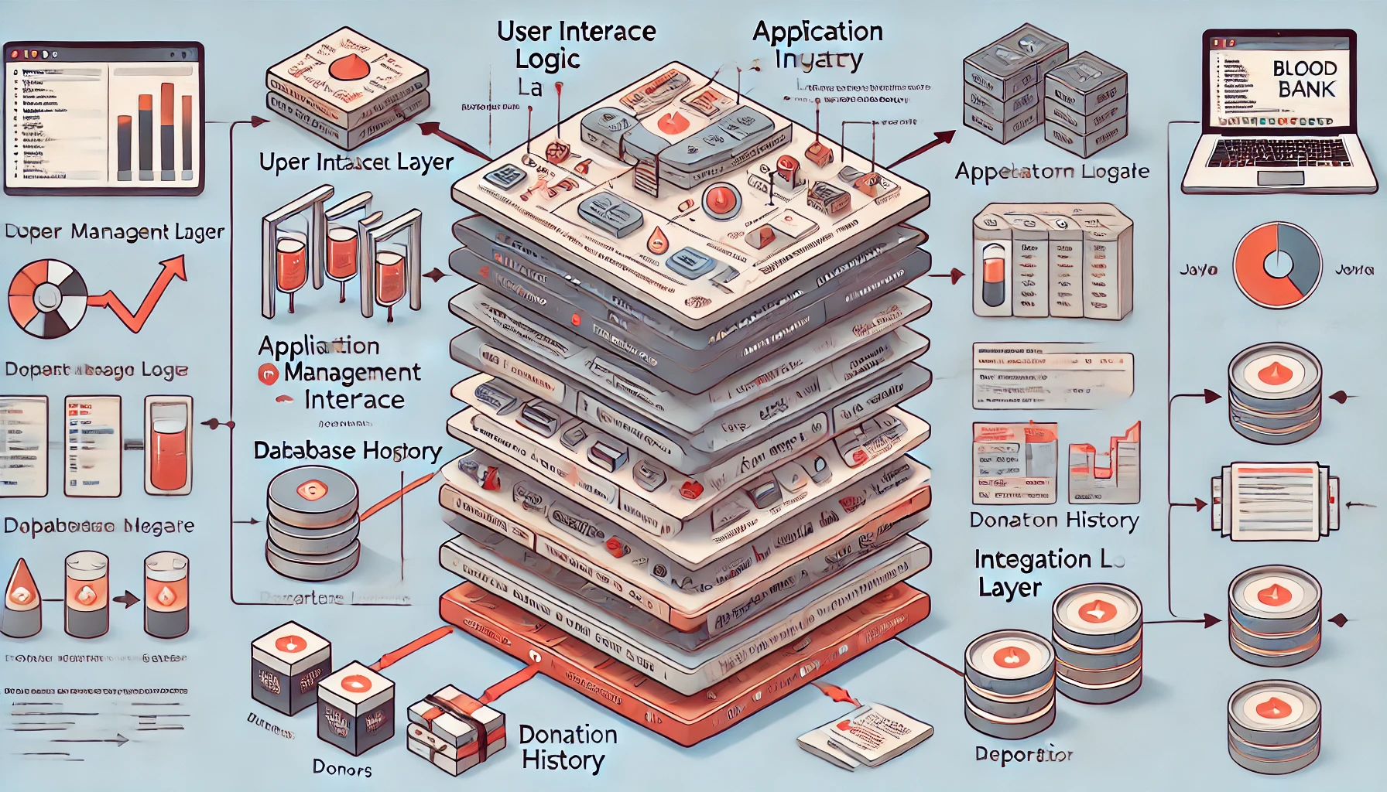

**CHAPTER 5**

**FUNCTIONAL DESCRIPTION**

The **Blood Bank Management System** is a robust Java-based application designed to automate and streamline the operations of blood banks, leveraging Object-Oriented Programming principles for modularity, reusability, and maintainability. The system consists of multiple interconnected modules to handle essential functionalities efficiently. The **Donor Management Module** allows staff to register new donors, update or delete existing records, and search for donors based on criteria such as blood group or last donation date. The **Blood Inventory Management Module** ensures real-time tracking of blood stock levels categorized by type (e.g., A+, B-, O-) and triggers automated alerts when inventory levels fall below a threshold. The **Donation History Module** records donation dates and tracks donor eligibility for future donations, maintaining a detailed history linked to each donor. The **Reporting and Analysis Module** enables administrators to generate comprehensive reports on blood inventory, donor activity, and usage trends, offering insights for decision-making and compliance. The system incorporates a **Search and Retrieval Feature**, which allows quick and efficient filtering of donor and inventory data during emergencies. Security is prioritized with features like role-based access control and encryption to protect sensitive donor information. A **System Administration Module** enables user account management, access permissions, and system maintenance such as database backups. The application integrates seamlessly with a MySQL database using JDBC to ensure efficient and secure data storage, retrieval, and management. With a user-friendly interface designed using Java Swing or JavaFX, the system is accessible even to non-technical staff, improving overall user experience. The platform automates manual processes, reducing human errors and operational delays while ensuring data accuracy and integrity. Notifications for low stock levels and real-time updates enhance operational readiness, especially in emergencies. Additionally, the system supports exporting reports in formats like PDF or CSV for external use and offers visual summaries of inventory trends. This scalable and adaptable solution can integrate with future enhancements like online scheduling or hospital network connectivity, making it an invaluable tool for improving the efficiency and reliability of blood bank operations.

**CHAPTER 6**

**SYSTEM DEVELOPMENT TESTING AND IMPLEMENTATION**

**6.1. SYSTEM DEVELOPMENT**

The **System Development** phase of the Blood Bank Management System involves translating the design into a functional application through coding, integrating components, and ensuring the system meets defined requirements. This phase emphasizes modularity, adherence to best practices, and thorough documentation.

#### 1. **Development Process**

* **Requirement Analysis:** Development began by reviewing the detailed requirements gathered during the analysis phase, ensuring all functional and non-functional aspects are addressed.
* **Technology Selection:** The system uses Java for programming, leveraging its object-oriented features, while MySQL serves as the backend for efficient data management. JDBC is utilized for database connectivity.
* **Development Tools:** Visual Studio Code (VS Code) is used as the integrated development environment (IDE), with Java-specific extensions for coding, debugging, and testing.

#### 2. **Module Development**

* The system was divided into modules, including **Donor Management**, **Inventory Management**, **Donation History**, **Reporting**, and **System Administration**, each designed and implemented as separate components.
* Classes were defined to represent entities such as donors, blood types, and inventory items, following principles of abstraction and encapsulation to promote reusability and maintainability.
* Interfaces were developed using Java Swing or JavaFX to provide user-friendly interactions.

#### 3. **Database Integration**

* The MySQL database schema was created, including tables for donors, blood inventory, and donation records.
* Relationships between tables were established to maintain data integrity, such as linking donation history to specific donors.
* The JDBC API was used to establish a secure and efficient connection between the application and the database.

#### 4. **Security Measures**

* Role-based authentication mechanisms were implemented to restrict access to sensitive functionalities based on user roles (e.g., staff, administrator).
* Input validation and data encryption were added to ensure data privacy and prevent security vulnerabilities.

#### 5. **Version Control**

* Version control systems, such as Git, were used to manage the development process, enabling collaboration and maintaining a history of changes for traceability.

#### 6. **Iterative Development**

* An iterative development approach was adopted, allowing each module to be designed, coded, and tested before integrating it with the system. This reduced the risk of errors and made debugging more manageable.

The system development process ensured that all features were implemented effectively, adhering to the design and technical requirements. It emphasized modular coding, secure database integration, and user-friendly interfaces, resulting in a robust application ready for the testing phase.

**6.2. TESTING**

The **Testing** phase ensures the reliability, functionality, and performance of the Blood Bank Management System before deployment. This process verifies that all modules operate as intended and meet the specified requirements.

#### **1**. **Types of Testing Performed**

* **Unit_Testing:**  
  Each module, such as Donor Management, Inventory Management, and Reporting, was individually tested to verify that its functions operate correctly in isolation. For instance, CRUD operations for donor records and blood inventory were validated.
* **Integration_Testing:**  
  Interactions between modules, such as updating inventory after a donation or linking donation history to a specific donor, were tested to ensure smooth data flow and functionality.
* **System_Testing:**  
  The complete system was tested as a whole to verify that it meets the requirements and provides a seamless user experience. This included validating end-to-end workflows like donor registration and generating reports.
* **Performance_Testing:**  
  The system's performance under different loads, such as handling multiple users accessing the inventory and generating reports simultaneously, was evaluated to ensure it meets performance benchmarks.
* **Security_Testing:**  
  Role-based access control was tested to ensure only authorized users could access sensitive data or perform critical actions. Input validation was tested to protect against SQL injection and other vulnerabilities.

#### 2. **Test Scenarios and Cases**

* **Donor Management:**
  + Scenario: Registering a new donor with valid data.
  + Test Case: Verify that the donor record is saved in the database correctly.
* **Inventory Management:**
  + Scenario: Updating blood stock after a donation.
  + Test Case: Ensure inventory levels reflect the change accurately.
* **Report Generation:**
  + Scenario: Generating a blood inventory report for a specific date range.
  + Test Case: Confirm the report includes the correct data and format.

#### 3. **Testing Tools and Techniques**

* Manual testing was performed for user interfaces and workflows.
* Automated testing tools were used for repetitive tasks like regression testing and performance benchmarking.

#### 4. **Bug Identification and Resolution**

* Detected bugs, such as incorrect data retrieval or system crashes during concurrent access, were logged and resolved promptly.
* Retesting was conducted to verify the fixes and ensure no new issues arose.
* The rigorous testing phase ensured that the Blood Bank Management System is reliable, secure, and ready for deployment. The process identified and resolved potential issues, guaranteeing optimal performance and user satisfaction.

**6.3. IMPLEMENTATION**

The **Implementation** phase of the Blood Bank Management System involves deploying the developed and tested application into the intended environment and ensuring it functions effectively for end-users. This phase includes setting up the system, training users, and configuring the environment for optimal performance.

#### 1. **Deployment of the Application**

* **Environment Setup:**
  + Java Runtime Environment (JRE) was installed on all machines to support the execution of the Java application.
  + MySQL Server was installed and configured to host the database for managing blood bank records.
  + JDBC drivers were integrated into the system for seamless communication between the Java application and the database.
* **Code Deployment:**
  + The application code was packaged as an executable JAR file for easy installation.
  + Configuration files, such as database connection parameters, were adjusted for the target environment.

#### 2. **Database Initialization**

* The MySQL database schema, including tables for donors, blood inventory, and donation records, was deployed.
* Initial data, such as default user accounts and sample inventory records, were inserted for system testing post-deployment.

#### 3. **User Training**

* **Target Audience:**
  + Blood bank staff and administrators.
* **Training Sessions:**
  + Conducted sessions to familiarize users with the system's interface and functionalities, such as registering donors, managing inventory, and generating reports.
  + Provided a user manual with step-by-step instructions and troubleshooting tips.

#### 4. **System Configuration**

* **Role-Based Access Control:**  
  User accounts were created with permissions based on roles (e.g., staff and administrators).
* **Notification Settings:**  
  Low stock alerts and system messages were configured for timely updates.

#### 5. **Pilot Testing**

* A trial run was conducted in a controlled environment to validate the system's performance and user interaction under real-world conditions.
* Feedback from the pilot testing was used to make minor adjustments before the final rollout.

#### 6. **Final Rollout**

* The system was deployed fully across all intended locations, ensuring accessibility and reliability.
* A support team was assigned to address any immediate issues encountered during the initial days of operation.

**6.4. DATASET**

The **dataset** for the Blood Bank Management System is a structured collection of data designed to support the efficient storage, management, and retrieval of information critical to the system's operations. It includes tables such as **Donors**, **Blood Inventory**, **Donation Records**, and **User Accounts**, each serving specific purposes. The **Donors Table** stores personal details like donor ID, name, age, gender, blood group, contact information, address, and last donation date, ensuring accurate tracking of donor eligibility. The **Blood Inventory Table** maintains records of blood types, quantities, expiry dates, and storage locations to monitor availability and ensure timely utilization. The **Donation Records Table** links donation history to donors via foreign keys, recording details such as donation dates and units collected. The **User Accounts Table** manages authentication and role-based access, storing user IDs, usernames, encrypted passwords, and roles (staff/admin). Data is collected through manual entry and migration of existing records, with the dataset structured and normalized to minimize redundancy and maintain integrity. This dataset forms the backbone of the system, enabling seamless management of donor information, inventory updates, and secure user access.

**CHAPTER 7**

**CONCLUSION AND FUTURE ENHANCEMENTS**

**7.1. CONCLUSION**

The **Blood Bank Management System** demonstrates how technology can be effectively utilized to streamline and enhance the operations of blood banks. By leveraging Java programming, Object-Oriented Programming (OOP) principles, and MySQL database integration, the system provides an efficient, user-friendly, and scalable solution for managing donors, blood inventory, and donation records. The modular design and secure implementation ensure accuracy, reliability, and ease of maintenance, reducing the manual effort required and minimizing human errors. Comprehensive testing has validated the system's functionality and performance, making it ready for real-world application. This project not only addresses the immediate operational challenges of blood banks but also sets a foundation for future enhancements and integrations, thereby improving the overall efficiency and reliability of healthcare systems.

**7.2. FUTURE ENHACEMENTS**

The Blood Bank Management System has significant potential for growth and improvement to meet evolving needs. Some key future enhancements include:

1. **Online Appointment Scheduling:** Integration of a web or mobile platform to allow donors to schedule appointments for donations, improving convenience and operational efficiency.
2. **Real-Time Notifications:** Implementing SMS or email alerts for donors about upcoming donation eligibility or campaigns.
3. **Hospital Integration:** Connecting with hospital networks to streamline requests for specific blood types during emergencies.
4. **Inventory Forecasting:** Incorporating predictive analytics to forecast blood demand based on historical trends and upcoming events.
5. **Mobile App Development:** Developing a companion mobile application for staff and donors to access features like donation history and stock status on the go.
6. **Multi-Language Support:** Adding support for multiple languages to make the system more accessible to diverse users.
7. **Cloud Integration:** Migrating the database to a cloud platform for better scalability, real-time access, and enhanced data security.
8. **AI-Powered Donor Matching:** Using AI algorithms to match donors with recipients efficiently based on location and blood type.

These enhancements will extend the system’s capabilities, improve user experience, and further align it with modern healthcare demands.

**APPENDIX-1**

**SAMPLE CODE**

import java.sql.Connection;

import java.sql.DriverManager;

import java.sql.ResultSet;

import java.sql.Statement;

public class BloodBankDBConnection {

public static void main(String[] args) {

// Database credentials and URL

String url = "jdbc:mysql://127.0.0.1:3306/BloodBankDB"; // Replace 'BloodBankDB' with your actual database name

String user = "root"; // Replace with your MySQL username

String password = "Jyosjas_24"; // Replace with your MySQL password

// JDBC Connection

Connection conn = null;

Statement stmt = null;

try {

// Load MySQL JDBC driver

Class.forName("com.mysql.cj.jdbc.Driver");

System.out.println("Driver loaded successfully.");

// Establish connection

conn = DriverManager.getConnection(url, user, password);

System.out.println("Connected to the database.");

// Create a Statement object

stmt = conn.createStatement();

// Execute a query (example: fetch all donors)

String query = "SELECT * FROM Donors"; // Ensure the 'Donors' table exists in your database

ResultSet rs = stmt.executeQuery(query);

// Display results

System.out.println("Donors:");

while (rs.next()) {

int donorId = rs.getInt("donor_id");

String name = rs.getString("name");

int age = rs.getInt("age");

String bloodGroup = rs.getString("blood_group");

String contact = rs.getString("contact_number");

String address = rs.getString("address");

String donationDate = rs.getString("donation_date");

System.out.println(donorId + " | " + name + " | " + age + " | " + bloodGroup + " | " + contact + " | " + address + " | " + donationDate);

}

// Close the ResultSet

rs.close();

} catch (Exception e) {

e.printStackTrace();

} finally {

try {

// Close the Statement and Connection

if (stmt != null) stmt.close();

if (conn != null) conn.close();

} catch (Exception ex) {

ex.printStackTrace();

}

}

}

}

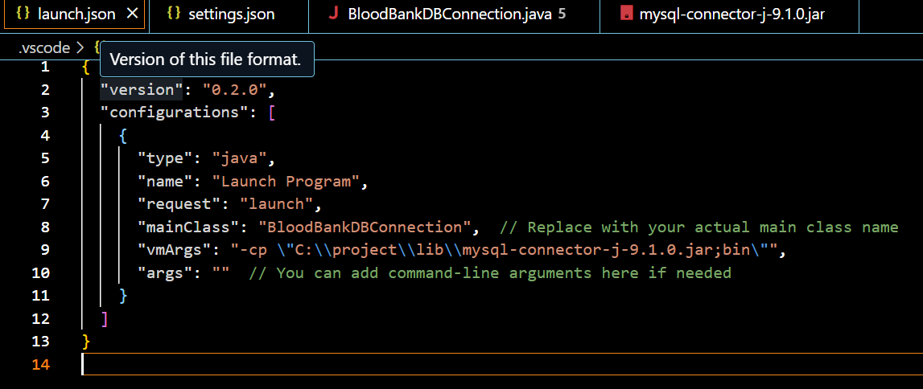

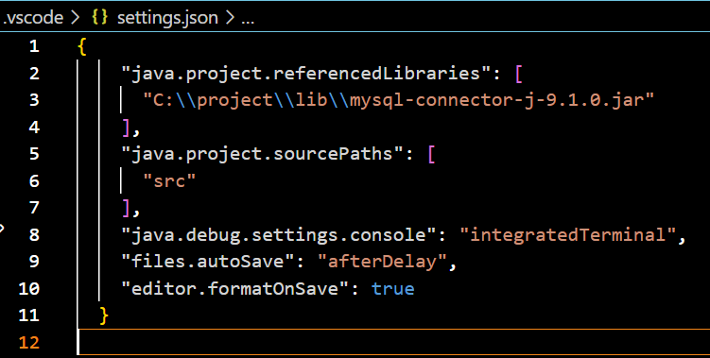

**APPENDIX 2**

**OUTPUT SCREENSHOTS**

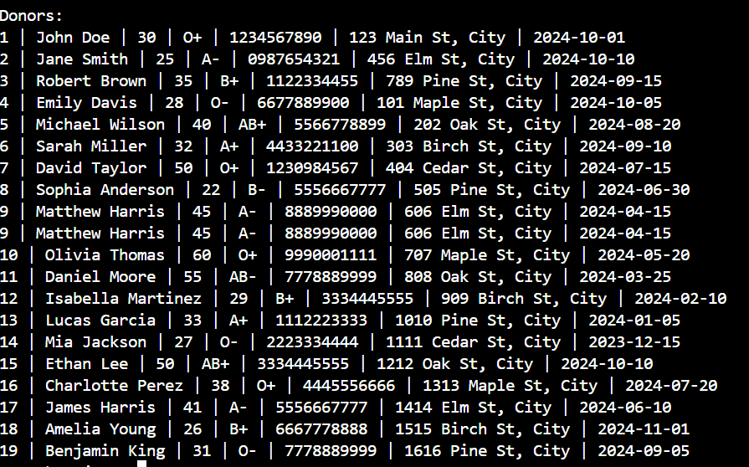

**REFERENCES**

[1].Blood Bank System using Database Security," authored by Reema Agarwal, Sonali Singh, Chanchal Atal, and supervised by Dr. Danie Kingsley in 2020, investigates the implementation of database security within the Blood Bank Management System. This study explores measures to protect and safeguard sensitive data, ensuring the security and integrity of blood donor and recipient information.

[2]. A Research paper, authored by Devanjan K. Srivastava, Utkarsh Tanwar, M.G. Krishna Rao, Priya Manohar, and guided by Balraj Singh, focuses on the "Blood Donation Management System." These authors, affiliated with Lovely Professional University in Jalandhar, India, delve into the development and functioning of a system that manages blood donations effectively, addressing the crucial aspect of donor and inventory management in the context of a blood bank.

[3]. "A Study on Blood Bank Management System" authored by A. Clemen Teena, K. Sankar, and S. Kannan, hailing from the Department of MCA at Bharath University in Chennai, Tamil Nadu, India, explores the intricacies of blood bank management. This paper delves into the operations and challenges faced by blood banks, highlighting the importance of effective management systems and technology in addressing these challenges. Collectively, these research papers provide valuable insights into various aspects of blood bank management and underscore the significance of secure database systems, efficient donor and inventory management, and technology in ensuring a steady and reliable supply of blood for medical purposes

[4]. Leitman S, et al. Hemochromatosis subjects as allogeneic blood donors: a prospective study. Transfusion. 2003;43(11):1538–1544.

[5]. Hillyer C, et al. Comparable safety of blood donation in high-risk autologous donors versus non-high risk donors and directed donors in a hospital setting. American Journal of Clinical Pathology. 1994;102(3):275–277.

[6]. Klapper E, et al. Confirmation of the safety of autologous blood donation by patients awaiting heart or lung transplantation. A controlled study using hemodynamic monitoring. The Journal of Thoracic and Cardiovascular Surgery. 1995;110(6):1594–1599.

[7]. Mann M, Sacks HJ, Goldfinger D. Safety of autologous blood donation prior to elective surgery for a variety of potentially high-risk patients. Transfusion. 1983;21(3):229–232.

[8]. Owings DV, et al. Autologous blood donations prior to elective cardiac surgery. Safety and effect on subsequent blood use. Journal of the American Medical Association. 1989;262(14):1963–1968.